Power BI Assignment 2 – DAX & Data Visualization
  - Calculated Columns:
  - Create a Calculated Column for 'Category Type':
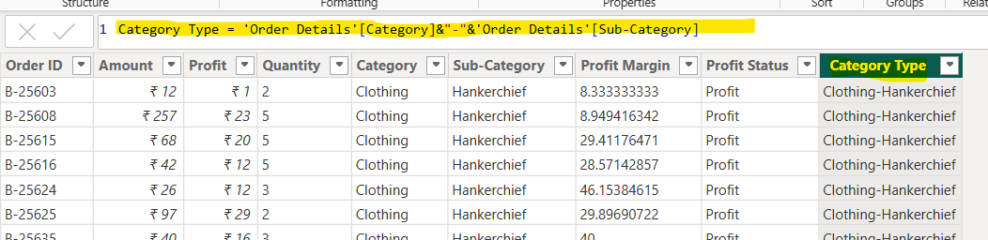

Calculate Revenue per Order in Order Details Table:
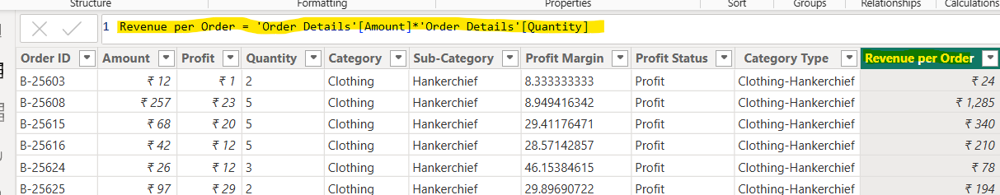

  - Create a Calculated Column to Categorize Sales:
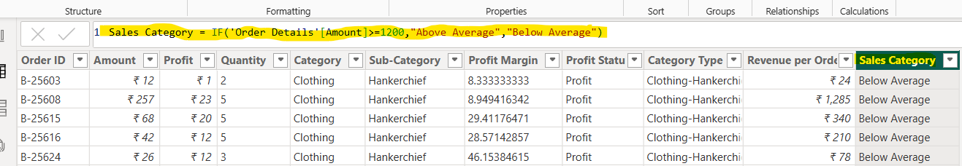

Calculated Measures:
Calculate Order Count:
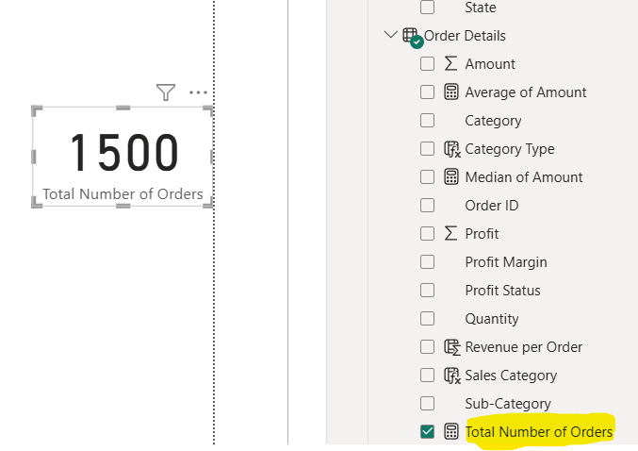

Calculate Average Profit in Delhi:
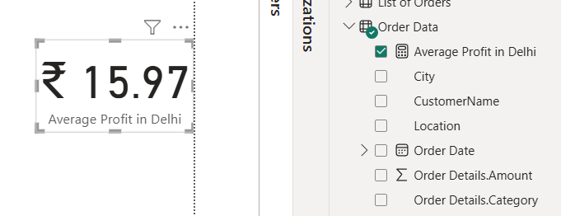

Calculate Year-to-Date (YTD) Sales:
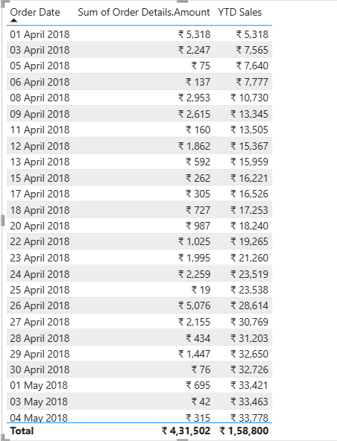
Data Visualization:
Sales Target Achievement by Category:
Compared actual sales with sales targets by category using a clustered column chart.
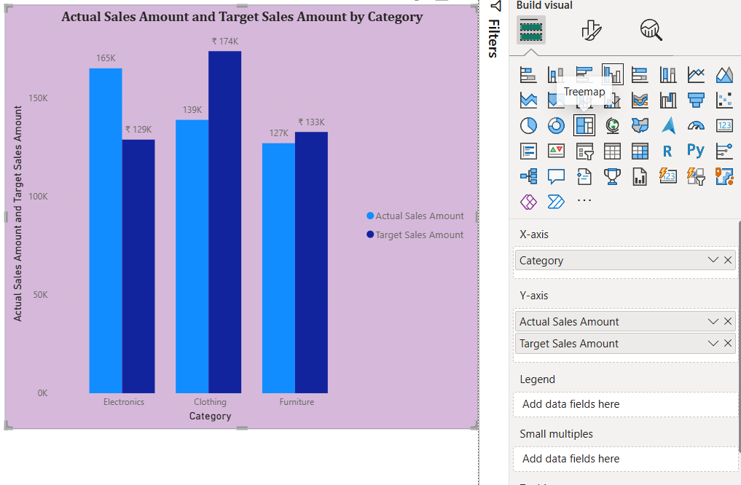
Max Profit Margin by Sub-Category:
Maximum profit margin for each sub-category of products using a Bar chart.
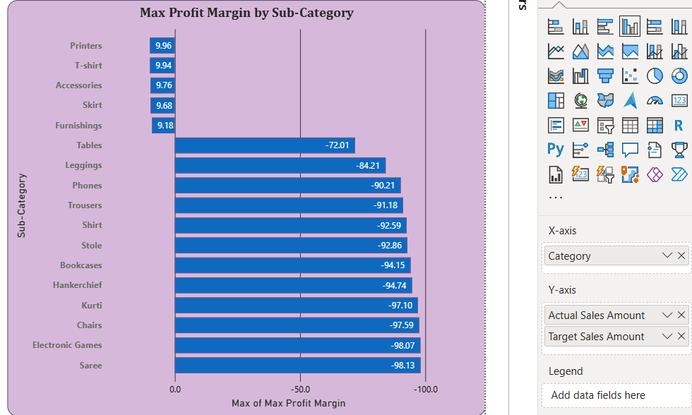
Monthly Sales Trend:
Show the trend of monthly sales over time using a line chart.
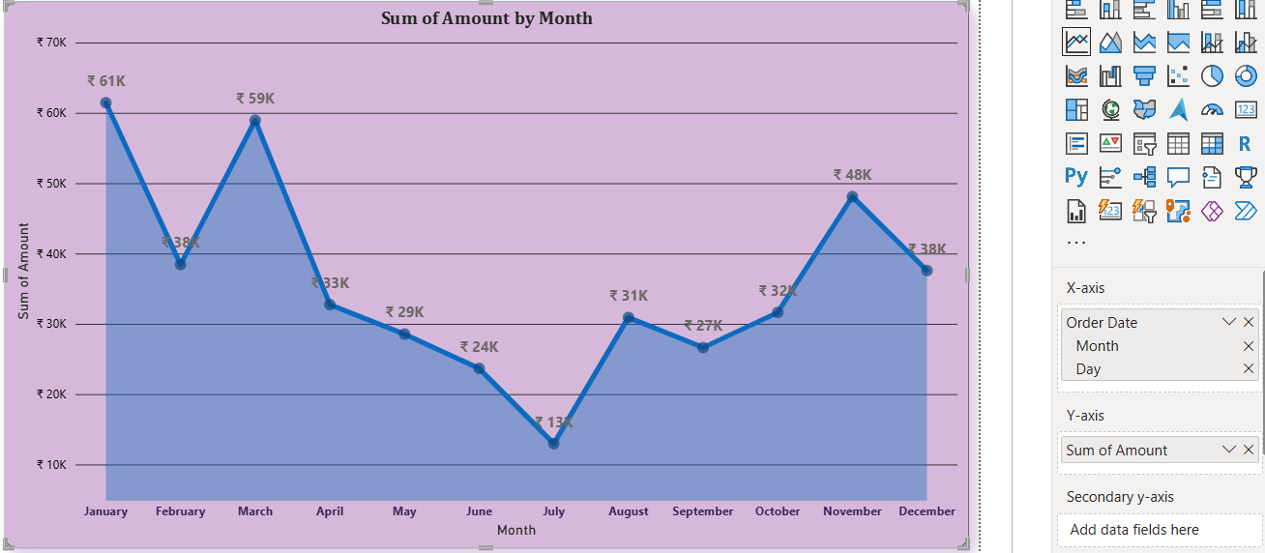

Comparison of Profit and Quantity by Sub-Category:
The relationship between profit and quantity sold for different sub-categories using a scatter chart.
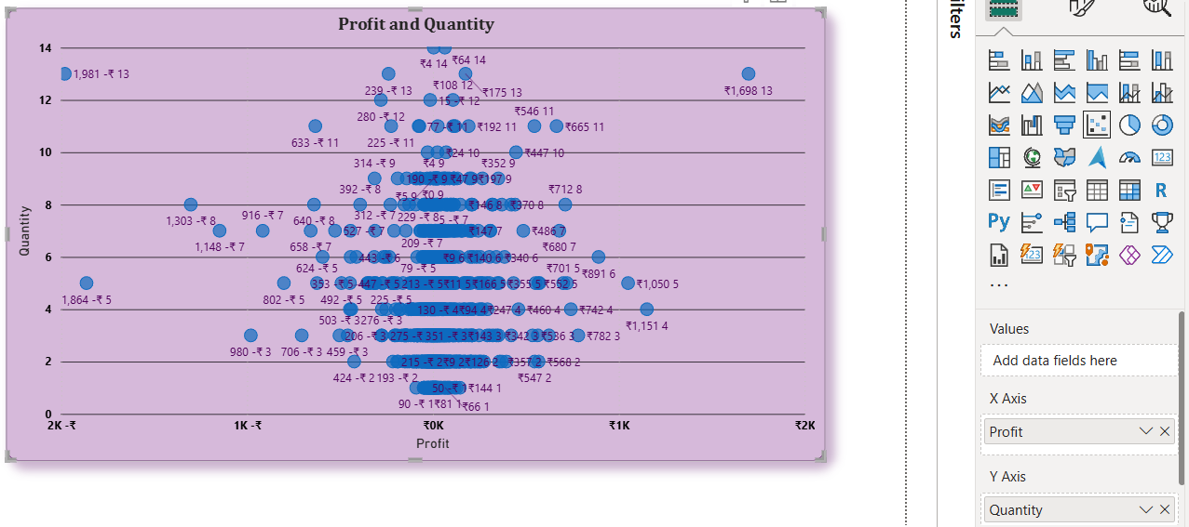

Comparison of Total Sales Amount and Target:
Created cards to succinctly display the total sales amount alongside the sales target for quick comparison and analysis. Also, created a multi-row card to display the minimum target for each segment.
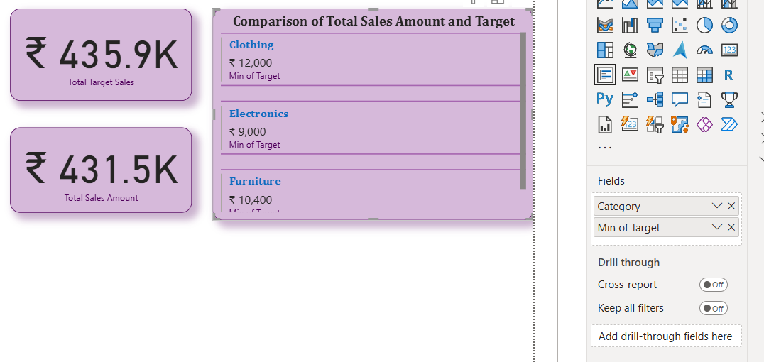
Sales Performance Matrix:
Build a matrix view to analyse how actual sales compare to sales targets across different categories and months.

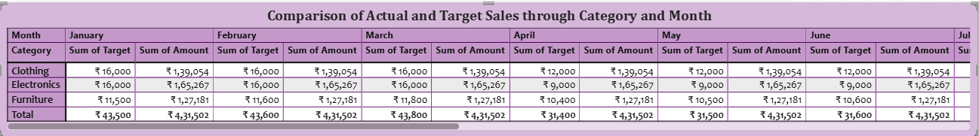
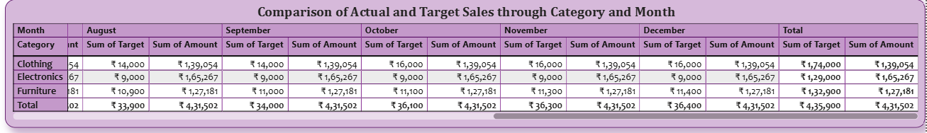

Geographic Sales Analysis:
Visualized total sales on a map by city to identify regional sales patterns.
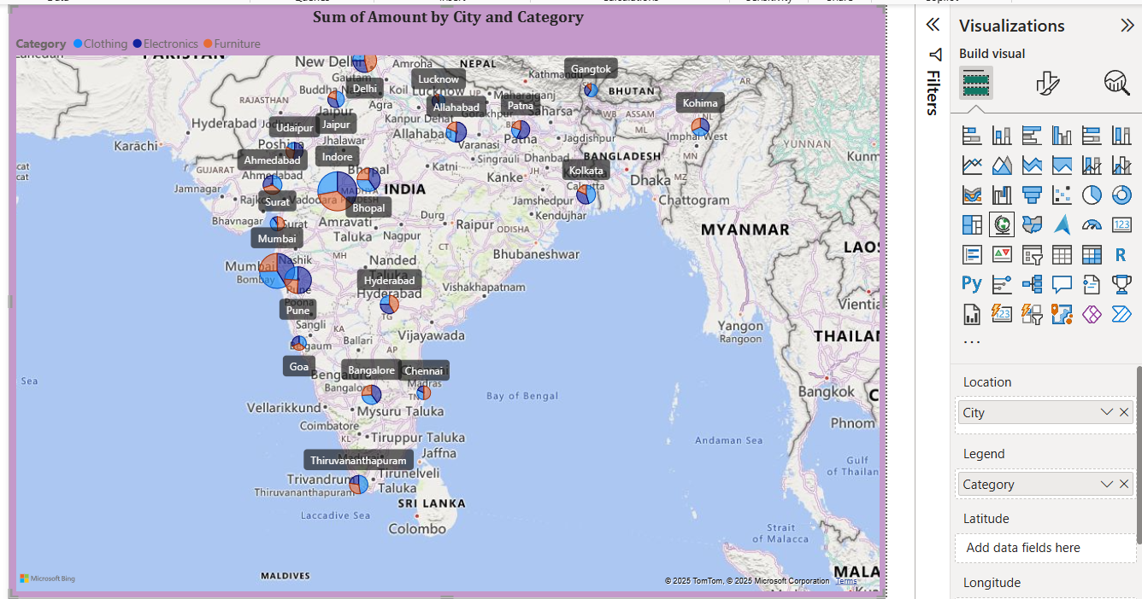

Sales Distribution by Sub-Category:
Represent the sales distribution across different sub-categories using a treemap.
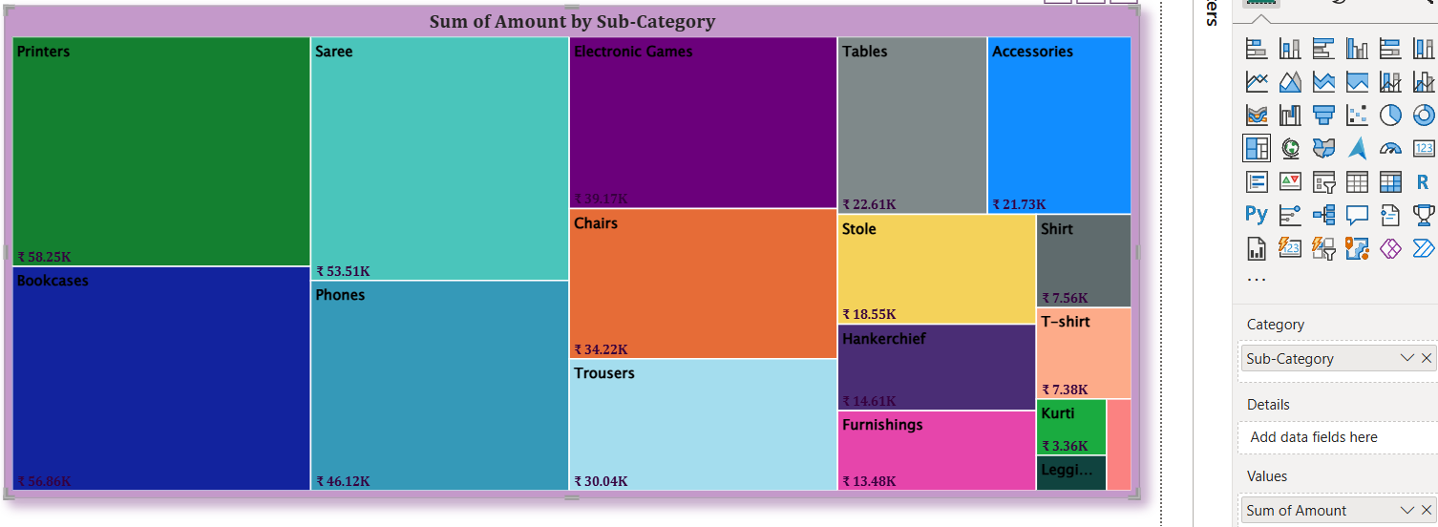

Order Count Analysis by State:
Create a funnel chart to visualize the distribution of order counts across different states.
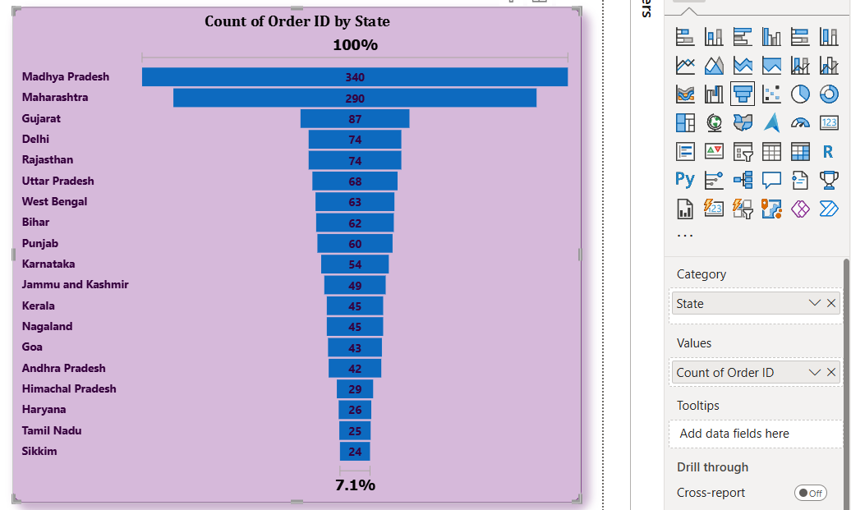

Dashboard Mobile Layout
Dashboard:
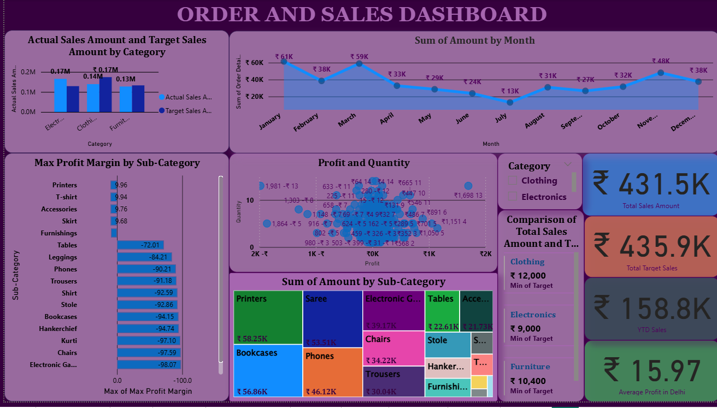
Mobile Layout:
